CISC7204 Data Science and Data Visualization
Assignment 02 Pair Project Proposal
UNIVERSITY OF MACAU

CHEN IAT HONG MC654102
TANG CHI IN MC660146

Topic: Attacking and Defensive Profiles of Premier League Teams with Similar Points
The 2025 to 2026 Season
Region: England, United Kingdom
Domain: Sports and Football Analytics

Research Question
How do attacking, defensive and player goal-contribution profiles differ among teams with equal calculated points in the 2025/26 English Premier League?

- Project Topic and Purpose
Revision of the Preliminary Proposal
Assignment 01 examined how attacking and defensive indicators relate to league points. This revision compares teams that finished on the same calculated points, and adds the distribution of player goals. Radar charts show the wider profiles. Match results show differences that season totals hide.
Supporting Questions
How do shooting volume, shot accuracy and opponent shots on target differ between these teams? How do the leading scorer's share and the top three scorers' share of player-attributed goals compare?
Project Purpose
The project uses the course's preparation and visualisation methods to make these comparisons. Equal points can come with different attacking records, different rates of goals conceded, and different concentrations of player goals. The analysis describes those differences.
Datasets and Scope
The match source ^{[1]}, season-2526.csv, contains 380 fixtures from 15 August 2025 to 24 May 2026, including results, goals and shooting statistics. The player source ^{[2]}, players_data-2025_2026.csv, contains 2,839 records across five leagues, including 551 Premier League player-club records covering the same 20 teams.
Assignment 01 produced team_analysis.csv by grouping match records by club. It is a derived table, not an independent source: goal and point totals are aggregates, while per-match figures and shot accuracy are calculated ratios. Team is the standardised club key linking the summaries. For Assignment 02, we rebuilt the table from the original matches, and all 240 checks across 12 fields and 20 clubs matched within numerical tolerance.

- Project Tasks and Progress
Analysis Tasks
Season totals and per-match rates were calculated from both sides of each fixture. Points are three for a win and one for a draw, with no administrative adjustments.
Each of the 190 unordered club pairs was considered once. Every equal-point pair is retained. Gaps of up to three points are the next comparison, and a gap of five points is the sensitivity check. Wins, draws, losses and margins are examined with the shooting statistics.
Club names were matched across the two files. For each team we calculated the leading scorer's share and the top three scorers' share of player-attributed goals. A transferred player keeps a separate record at each club. No minutes threshold is applied, because the shares describe full-season contributions rather than scoring rates.

- Preliminary Evidence and Visualization
The 190 club pairs include three equal-point cases: Brentford and Brighton on 53 points, Chelsea and Fulham on 52, and Everton and Newcastle on 49. Twenty-two further pairs have a gap of one to three points, so 25 pairs fall within three points and 44 within five. This section interprets the three exact-point cases. The other pairs are counted and left for the next stage.
Figure 1 compares five measures using a common scale across all 20 clubs. Each value is transformed to 0–100 using its league minimum and maximum. Higher values mean more of that measure, not necessarily better performance, so the polygon area is not an overall rating.
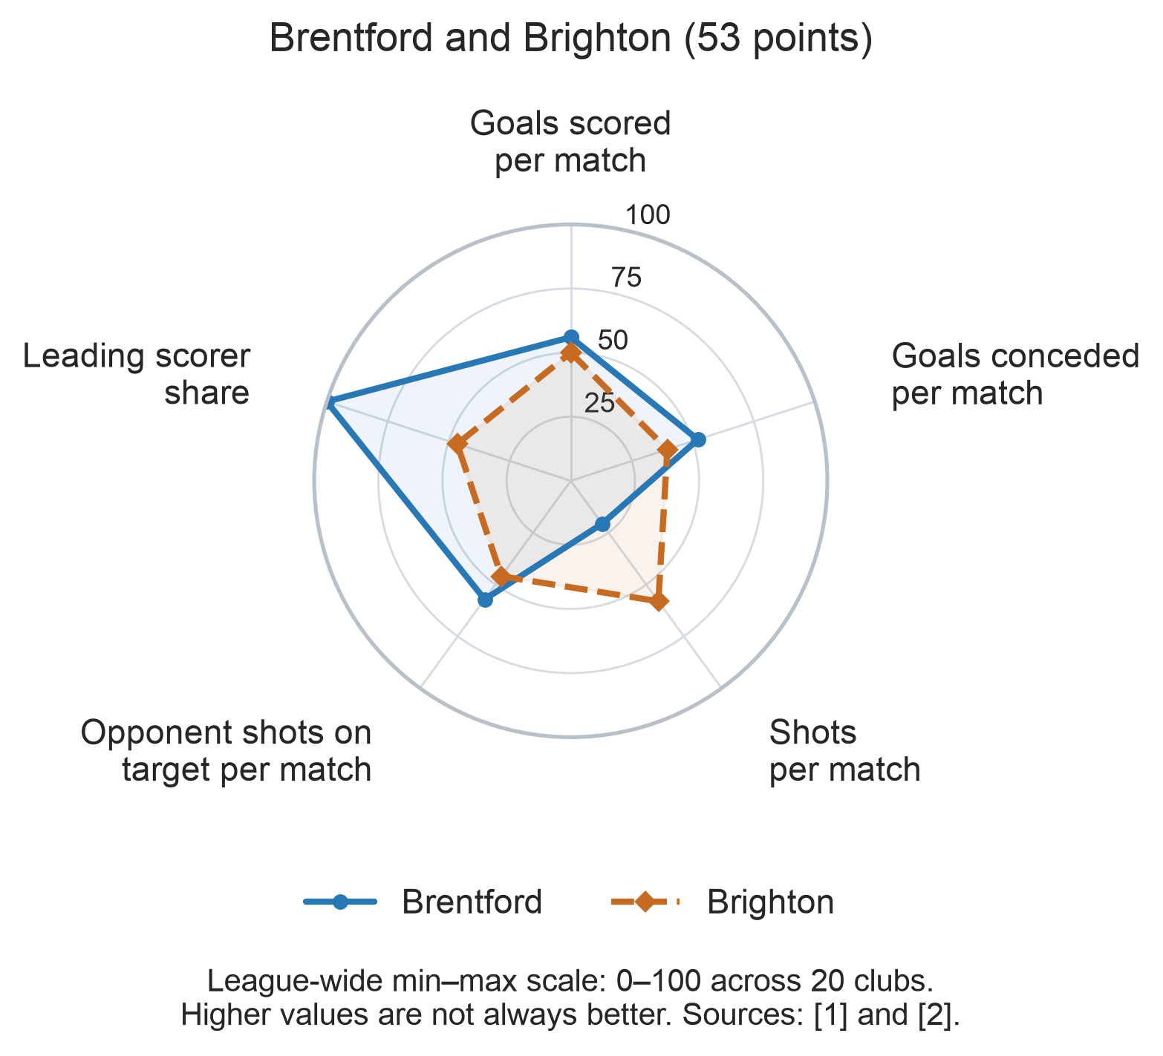
Figure 1. Radar profiles of Brentford and Brighton at 53 calculated points. Sources: match data ^{[1]} and player data ^{[2]}.

Both clubs earned 53 points from the same record: 14 wins, 11 draws and 13 losses. Brentford averaged 10.66 shots per match to Brighton's 13.03, yet scored 55 goals to Brighton's 52 and conceded 52 to Brighton's 46. Shot accuracy was close, at 36.3% and 35.6%, so the scoring gap sits in goals per shot rather than in the share of shots on target. Opponent shots on target were 4.26 and 3.89 per match. Brentford's leading scorer contributed 41.5% of its player-attributed goals, the highest share among the 20 clubs. Brighton's leading scorer contributed 25.5%, and its top three 43.1%, to Brentford's 69.8%. The shares use player-attributed goals, not total team goals. Both clubs' goal rates sit near the middle of the league scale. The gap in Figure 1 comes mainly from shot volume and scoring concentration.
Figure 2 retains actual goal rates for all three equal-point pairs, making the differences behind the radar profiles easier to interpret.
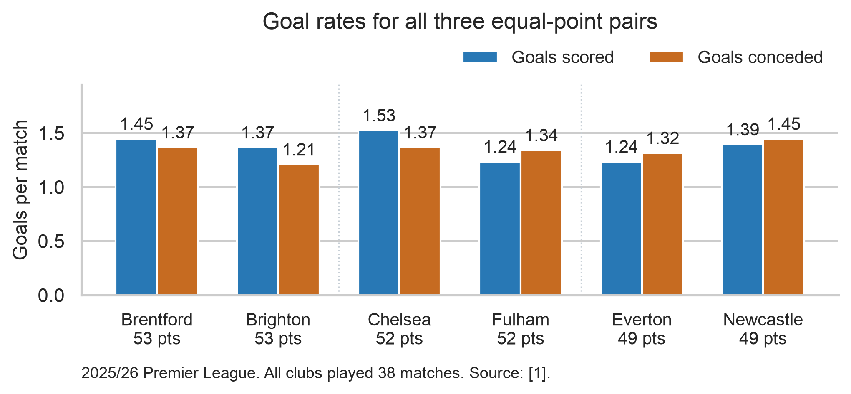
Figure 2. Goals scored and conceded per match for all three equal-point pairs. Each club played 38 matches. Source: match data ^{[1]}.

Chelsea and Fulham both finished on 52 points with different results. Chelsea's record was 14 wins, 10 draws and 14 losses; Fulham's was 15, 7 and 16. One extra win adds three points, and three fewer draws remove three, so the totals match. Chelsea scored 58 goals to Fulham's 47, with shot accuracy of 32.1% to 28.7%. Fulham won 10 matches by one goal, to Chelsea's four. Everton and Newcastle repeat the same pattern at 49 points: Everton was 13–10–15 and Newcastle 14–7–17. Newcastle scored and conceded more, 53 and 55, to Everton's 47 and 50. The notebook also contains radar charts for these two pairs.
Source Reconciliation and Interpretation
The match source records 1,045 goals, and the player source totals 1,005. The 40-goal gap equals the player file's league-wide own-goal total. Club-by-club attribution is still unverified, so the scorer shares stay on player-attributed goals. Goalkeeper measures that could not be reconciled are excluded.
The study describes one season. The three equal-point pairs use six different clubs. In the three-point and five-point windows, the same club can appear in more than one pair, so those later comparisons will not be independent. Rebuilding the Assignment 01 table shows that the two match aggregations agree. It does not check every record against official match reports.

- Project Criteria for Success
The analysis meets its criteria if it answers the questions, includes every exact-point case, and states the units, the scorer-share denominators, the radar scaling and the limitations. From a fresh kernel, the notebook must reproduce the submitted tables and figures without changing the input files. Small differences will be reported rather than set aside.

- Project Collaboration
CHEN IAT HONG (MC654102) coordinates the analysis and drafts the report, calculates season totals, per-match rates and points, applies the equal-point and near-point rules, prepares the radar charts and grouped bars, writes the interpretation of the three equal-point cases, and will extend the outcome and shooting comparisons.
TANG CHI IN (MC660146) handles the player data and matches club names, calculates the leading-scorer and top-three shares, compares team goals with player goals and own goals, keeps the decision log and checks the written figures, reviews the interpretation so the claims stay descriptive, and will extend the scorer-share comparisons.
Two members check each other's work before reporting a result, review the plan, the code and the final wording, keep the raw files unchanged and use one shared version, then run the notebook from a fresh kernel and review the report together.

Dataset References
[1] DataHub. English Premier League football, season-2526. Original provider: Football Data UK. Dataset page and downloads (https://datahub.io/football/english-premier-league)
[2] Sidorowicz, H. Football Players Stats 2025-2026. Kaggle. Player dataset page (https://www.kaggle.com/datasets/hubertsidorowicz/football-players-stats-2025-2026)

